Wiremu Weka Treks the Alps Curriculum-led Children’s Activities

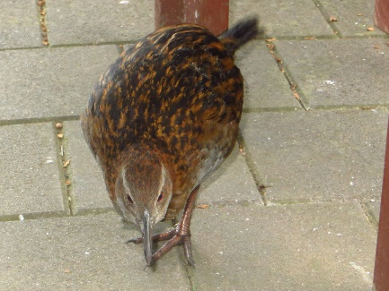
BACKGROUND:
Kinsa Hays experienced many of these adventures herself when travelling around the South Island for three years. She has become an advocate for the land, the endangered birds and native creatures. Children are the future carers. She hopes her values will rub off on them; the iconic scenery of the west-east crossing, the endangered birds Wiremu encountered, the spirituality, biology and history and topuni conferred on it by Maori. Each distinctive ecosystem that Wiremu Weka traversed is a classic example of how living things interact with each other. A retired teacher, Kinsa had fun devising these activity ideas and hopes the children do too, especially the boys.

USING THE BOOK IN THE CLASSROOM

Wiremu Weka Treks the Alps & the Science Curriculum
The subject overlaps each strand of the curriculum. How the story fits in with learning objectives:

LIVING WORLD strand
- Understanding how living things interact with each other and with the non-living environment (e.g. differences across the range of ecosystems.)
- Understanding life processes. (e.g. the cave weta’s method of over-wintering at altitude.)

PLANET EARTH strand
- Understanding the sub-system (e.g. the interdependence of sub-systems of snow and ice and water.)
- Understanding human impact (e.g. kaitiaki guardianship and the protection of topuni; introduction of mustelids, land use changes, endangered birds, including the demise of the moa.)

PHYSICAL WORLD strand
- Exploring the forces that created New Zealand (e.g. the formation of Gondwana and the Alps; erosion and Cave Stream; limestone and Castle Hill, and the formation of the Canterbury Plains.)
- How coal was formed (e.g. Brunner Coalfield seams); mining alluvial gold (e.g. historic gold rush in Greymouth.)

MATERIAL WORLD strand
- Understanding the role of chemistry in the world (e.g. Kura Tawhiti; limestone properties [CaCO3]; the Brunner mine explosion (e.g. fire damp, methane and air); and black or choke damp (nitrogen and carbon dioxide), and the Pike River Mine disaster) and West Coast goldmining (e.g. use of mercury amalgam to bind to the gold)

Wiremu Weka Treks the Alps – SUGGESTED ACTIVITIES.

LIVING WORLD strand
https://www.greatjourneysofnz.co.nz/tranzalpine/

Maps and Games
‘The Tranz-Alpine Express is a world-famous train journey that travels between Greymouth to Christchurch in the South Island over the spectacular Southern Alps. Ascend through thick stands of native beech forest to Arthur’s Pass for a halt in a breath-taking alpine landscape. Traverse the mighty Alps, travel alongside the ice-fed Waimakariri River and enjoy thrilling vistas over deep gorges. Cross the fertile farmlands of Canterbury then you will arrive at your destination.’
TranzAlpine express video https://www.youtube.com/watch?v=KYFoai2BzPA

Imagine you are on the Tranzalpine Express about to traverse the Alps. From the story chapters, create a storyboard of what you would see between Greymouth and Christchurch railway stations:
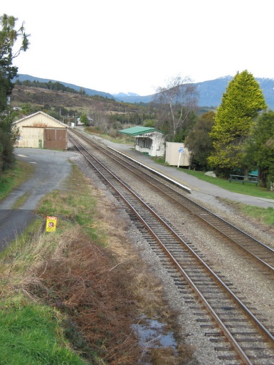
- Before arriving at Moana Station
- While the train halts at the station
- Between Moana and Arthur’s Pass
- You get off at Arthur’s Pass to have a quick lunch while the train waits. What can you observe?
- In the Waimakariri Gorge
- Crossing the Canterbury plains

Draw an altitude map of the terrain Wiremu Weka trekked. Name the two highest points and two lowest points.
Why are there different types of plants and native creatures at different altitudes? How do they adapt to the conditions? Consider ferns, grasses, rainforest, the wrybill, cave weta and black stilt.
Why are New Zealand’s animals and birds unique?
Create a card game or Snakes and Ladders type of board game with the different creatures and climatic conditions you find while trekking the Alps.
Write a play about Wiremu Weka and an adventure with another native bird.

Evolution
What happened to the Haast’s Eagle and the moa?
If you were a Maori warrior 500 years ago and had to feed your whanau, how would you catch a moa?
How are we saving the kaki/black stilt?
How are we saving Australasian grebe?
What can people do to help our endangered birds and invertebrates?
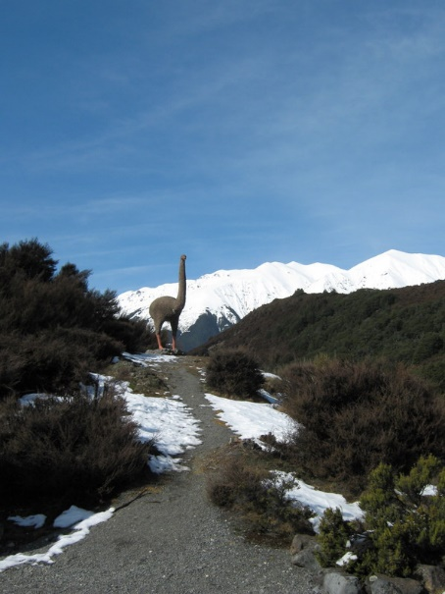

Planet Earth and Beyond strand

Weather patterns
Draw and explain the cycle of the weather pattern as it crosses the South Island from the Tasman Sea.

Investigate what happens while the weather pattern crosses the Tasman Sea: when a front reaches the mountains and after the front crosses the mountains.

- What happens to the Southern Alps during each seasonal change to the land?
- How are braided rivers formed?
- Why are the main West coast rivers different to the main East coast rivers?
- Where does the water for irrigation in the Canterbury Plains come from?

Human impact on the land
What is topuni?
How can we be kaitiaki of our land?
What is the Braided River Care code?
How are the children of Twizel School helping?
How can farmers help?

Back in history
Imagine you lived 500 years ago. You are a Maori warrior or wahine travelling in the Kura Tawhiti area. What would you be wearing and carrying? Why would you be going there? Where do you shelter? Is the land any different? Are the birds different?
Make ‘rock art’ drawings of the things you might have seen around you using red paint, black charcoal and ochre pigment on dark paper and textured pale paper.

Physical World strand
In the beginning:
- What forces created this land?
- Why can we find seashells high up on the hills?
- Are the Southern Alps getting higher?
- Can you eat dinner off a tectonic plate?

http://www.teara.govt.nz/en/mountains/page-3
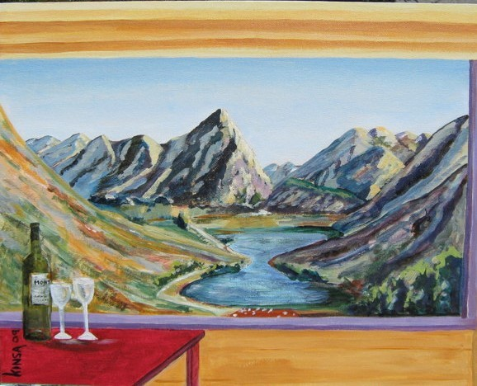
Moana Rua/Lake Pearson painted by Kinsa Hays

Karst Country
How was Cave Stream created?
Go to a beach with a stream running into it. Observe how it erodes the sandy banks beside it.
Create an erosion trial with sand in the sandpit, or with soil. Gently pour water in a riverbed you created in the base substance and see what happens.
Geology – what type of rock creates karst landscapes?
How were the strange land sculptures made?

Now have a go at making your own land sculptures. What material could you use? Can a group create their own Castle Hill?

Canterbury Plains puzzle
Mix some different green, brown and yellow colours. Paint a square of cardboard with them. Let it dry. Draw mosaic shapes like fields and roads over it. Cut it up to make a puzzle of the fields of Canterbury. What crops might be growing in the fields?

Material World strand
The study of matter
Water – symbol H²O
What changes does it undergo in the environment of the Alps? What force creates the change?
Experiment – freeze a measured cup of water in an ice tray. Observe how long it takes to change form and what energy is required to do it.
Remove it from the freezer. Place in the sun. Observe how long it takes to change form and what energy is required to do it.
Measure the liquid. Is there a difference?
Ask an adult to help you with this next experiment!
Put the water into a saucepan. Bring to the boil and boil for 5 minutes. Measure the difference in the amount of water left.
What has happened?

Limestone – chemical symbol CaCO3
What is limestone? http://www.softschools.com/facts/rocks/limestone_facts/370/
(Calcium carbonate (elements & compounds.) A white crystalline salt occurring in limestone, chalk, marble, calcite, coral, and pearl)
How is it used?
(In the production of lime and cement)

Try a chemical experiment with limestone and vinegar: http://www.chemicalforums.com/index.php?topic=48540.0

Mercury – symbol Hg
What is mercury? https://www.thoughtco.com/mercury-element-facts-608433
How is it used nowadays?
How did the old goldminers use it?
What form does mercury take?

Copper – symbol Cu.
What is copper? www.thebalance.com/copper-applications-2340111
How did the old goldminers use copper?
How is it used today?

Environmental sustainability
How can we help the planet?
How can farmers help our country?
If we do nothing, how will it affect climate change?
How do fossil fuels add to climate change?
What might happen to the river birds in the future?
What is nitrate leaching and what happens to water quality then?
What is a wetland and who looks after it?
What is extinction?
How many birds are on the endangered list? Which are they?
What is a ground bird and why are they vulnerable?
How can using the sun as a source of power help climate change?
How can you communicate what you’ve learned to people who make the decisions?
Does it matter if you don’t do anything?

Wiremu Weka Treks the Alps is available from Wheelers Books, Total Library Solutions, Academy Books. Or check out https://www.kinsahays.com/

